Introduction to
MEDIA WRITING

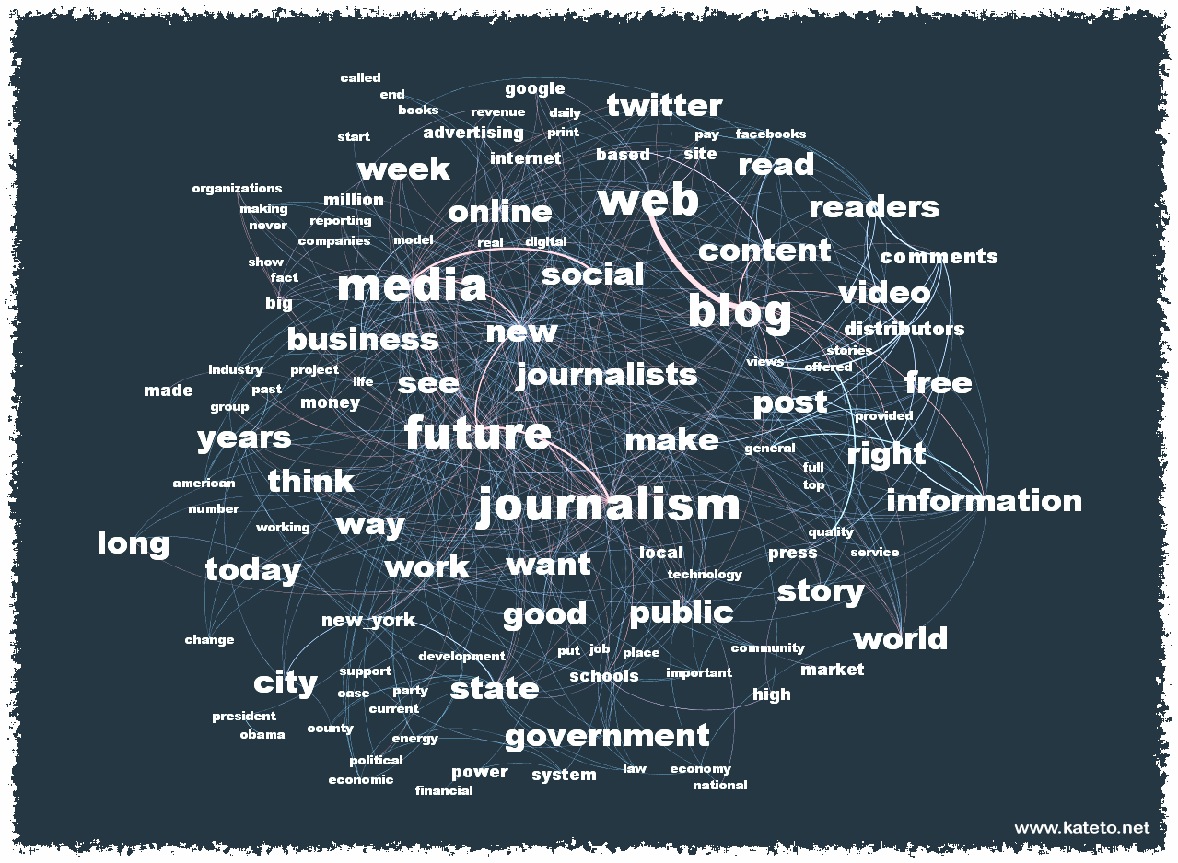

“Journalism can never be silent: that is its greatest virtue and its greatest fault. It must speak, and speak immediately, while the echoes of wonder, the claims of triumph and the signs of horror are still in the air.”
– Henry Anatole Grunwald, former editor in chief of Time, Inc.

This course is an introduction to writing for the media professions.

It should help you to develop and improve basic writing and reporting skills, as well as introduce you to some of the basic issues involved in these types of reporting.

Assignments require you gather, analyze, organize and present information to a general audience on a timely basis and following the rules of the Associated Press Stylebook.

Emphasis will be placed on a journalistic style of writing, which will serve you in all areas of mass communication.

It is likely this will be a different style of writing than you’ve done before. It requires breaking down old habits, and forming new ones.

OBJECTIVES
The skills you learn and refine in this course are pervasive, meaning that you will need them for everything you do academically and professionally. Professors and employers want and need curious people who know how to engage with others, to ask good questions and, perhaps most importantly, to write.
- Write clearly and concisely, following the rules of the Associated Press Stylebook.
- Paraphrase information and attribute it correctly.
- Gather and present facts and quotes clearly and accurately.
- Organize and prioritize information effectively to tell a story.
- Evaluate facts and information, and identify essential news values.
- Write a news release for media distribution.
- Understand the meaning of libel and identify potentially libelous statements in a written text.
- Identify and reasonably discuss common ethical dilemmas in journalism.

EXPECTATIONS
In this course, I expect students to learn, understand and use AP style. I also expect you to think critically, attend class, ask questions, engage and complete assignments. I also expect you to be honest, accurate, respectful and on time.

You can expect me to be available to help you succeed in this class – and beyond – in every reasonable way. You can expect me to listen to your concerns and to be fair in assessing and/or acting upon them. You can expect me to act like an editor and try to help you improve.

REQUIRED MATERIALS
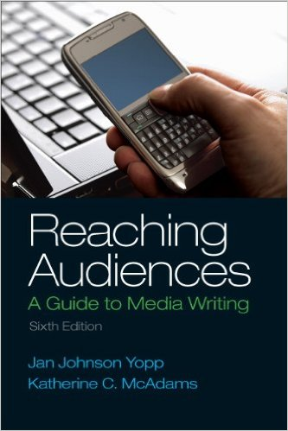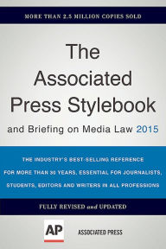

- Reaching Audiences: A Guide to Media Writing (Sixth Edition) by Jan Johnson Yopp & Katherine C. McAdams
- The Associated Press Stylebook 2015
- A dictionary and thesaurus
- A digital audio recorder (You can use a smartphone, or laptop)

ASSISTANCE
If you have health or educational needs, please inform me within the first week of the semester. Consistent with its responsibilities, Quinnipiac University also provides reasonable accommodations to promote equal educational opportunity. The University provides staff members to ensure compliance with the ADA and Section 504. These staff members work directly with students, faculty and staff regarding reasonable accommodations and other assistance as needed. If you require assistance beyond what I can provide, please contact John Jarvis, Coordinator of Learning Services at 203-582-5390 or John.Jarvis@Quinnipiac.edu.

Understanding and using the basics of grammar, punctuation and writing structure are expected. If you are having difficulty with this, please seek assistance from the QU Learning Center at TH 119, or call (203) 582-8628.

COURSE POLICIES
Quizzes: Quizzes will be given at the beginning of class. There will be no make-ups. (One quiz score will be dropped.)

Attendance: Attendance is mandatory. I track attendance through the daily quizzes. You are permitted one absence, which is why one quiz score is dropped.

Engagement: Engage; you’re here so you might as well learn. Please keep laptops and smartphones stored during class to prevent the urge to disengage.

Academic Integrity: Familiarize yourself with Quinnipiac University’s policy on Academic Integrity. (Available in full here.)

GRADING
Your grade will be comprised of the total score of the following:
- Four (4) writing assignments (400 points each. 400 total = 40 percent of final grade)
- One (1) major writing assignment (200 points = 20 percent of final grade)
- One midterm (100 points = 10 percent of final grade)
- Homework/in-class assignments (100 points = 10 percent of final grade)
- Quizzes (100 points = 10 percent of final grade)
- Final essay/presentation (100 points = 10 percent of final grade)

Writing Assignments: Writing assignments will be turned in via email, using MICROSOFT WORD .doc or .docx and double-spaced in 12-point font, unless otherwise noted. Check to be sure the document is attached, and double check after you have sent it that it went through. I suggest you cc yourself for proof it is sent/received if you email it. Please keep a copy. The excuse “this was in my outbox” does not cut it.

Writing Assignment Format: The following information should appear on the upper left-hand corner of the first page of all your stories:
Student's name
Course name and section
Professor's name
Story slug/first draft or rewrite
Date
Word count

Remember, there’s a reason “DEAD” makes up half the word “deadline.” Late assignments will not be accepted. The following will result in zero points for a writing assignment: Misspelled names and late assignments. The following will result in a failing grade for the class: Made-up sources.

REPORTERS MUST SELF-EDIT. In the real world, editors aren’t fans of reporters that file sloppy copy. So learn now to check spelling, punctuation and flow. Double-check names and titles.

Criteria for grading include accuracy, completeness, newsworthiness and significance of information, reader interest, fairness, organization of story, clarity, conciseness, precision of language, grammar, punctuation, spelling and proper use of style.
GRADING SCALE / RUBRIC
Grade %/Point Range Grade
> 930 A
900-929 A-
870-899 B+
830-869 B
800-829 B-
770-799 C+
730-769 C
700-729 C-
670-699 D+
630-669 D
600-629 D-
<599 F

A = Outstanding: Exceptional application of basic principles and concepts; Clean, concise copy that correctly utilizes AP style and proper grammar, punctuation and usage; written in a fashion that shows you understand the information, no opinionated thoughts without attribution; includes the five Ws and How.
What is an “A” writing assignment?
  - Information is well organized.
  - Lede is strong.
  - Grammar mistakes are few and require minimal editing.
  - Writing demonstrates a clear focus.
  - Sentences are clear and concise.
  - All facts are accurate and verifiable.

B = Good: Thorough application of basic principles and concepts; writing assignments are completed using some concepts and evidence examined in course material and include some critical and independent thought. Mostly clean, concise copy that - for the most part - utilizes AP style and proper grammar, punctuation and usage.

C = Average: Adequate understanding of basic principles and concepts that meets minimum requirements, writing assignments are completed using relative concepts and evidence examined in course material. Some style, grammatical or usage errors; writing is loose and comes in and out of journalistic focus.

D = Below Average: Inadequate and incomplete understanding of basic principles and concepts; writing assignments lack journalistic style; grammatical and/or usage errors are present; writing mostly lacks journalistic focus and is disorganized.

F = Poor: Little to no understanding of basic principles and concepts; writing is error-riddled and lacks structure and clarity.

UNIVERSITY/DEPARTMENT LEARNING OUTCOMES
Quinnipiac University has established Essential Learning Outcomes and learning paradigms. They include Interpersonal Proficiencies: Written communication, oral communication, responsible citizenship, diversity awareness & sensitivity and social intelligence, and Intellectual Outcomes: Critical thinking & reasoning, scientific literacy, quantitative reasoning, information fluency, creative thinking and visual literacy.
More on these outcomes is available here.

The Department of Journalism states that its mission is “to prepare journalism professionals who reflect and can effectively report on the diversity of the human experience.” Students who graduate with a degree in journalism should be able to:

1. Demonstrate the ability to research, report, write and edit news stories that conform to professional journalism standards, including the ability to apply basic numerical and statistical concepts.

2. Demonstrate command of the techniques used to produce and present news in print, broadcast and digital environments, and understand the interconnectedness of these systems.

3. Demonstrate familiarity with the history of journalism, its social responsibility and the underpinnings of its practice in a culturally and racially diverse society.

4. Understand the implications of the First Amendment and the role journalism plays in democracy.

5. Engage in the ethical practice of journalism.

