JRN380: FUNDAMENTALS OF DIGITAL JOURNALISM

PROFESSOR: Molly Yanity, Ph.D. OFFICE: CCE 344
OFFICE HOURS: Mon 1-4 p.m., Tues 2:30-5 p.m., Wed1-4 p.m. EMAIL: molly.yanity@quinnipiac.edu

REQUIRED TEXTBOOKS & READING
- There are no required texts for this class
- However, there are several reading/viewing assignments in the form of PDFs, and links that are available on the class site, or sent through Slack.
REQUIRED EQUIPMENT – A smartphone will suffice for many assignments, but it is likely you will need to borrow equipment from the equipment room in the lobby of CCE.
- Digital camera
- Digital audio recording device
- TWITTER ACCOUNT (follow @mollyyanity and @qujournalism)
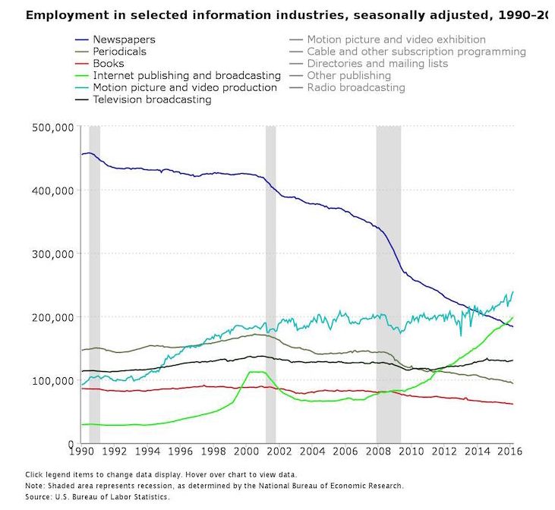
PURPOSE/OBJECTIVES
This is a professional-style course in which you will produce and publish a public website.
It should help you understand philosophies of “digital journalism” while developing and improving basic reporting, multimedia and analytical skills in a competitive environment.
Assignments require that you gather, analyze, organize and present information on digital platforms to a specific audience on a timely basis.
By the end of this class, you should have been introduced to and able to practice data-centered reporting and verification practices, collaborated to build a professional and public website, mastered digital presentation and theories, understand basic audio and video editing programs such as Audacity and Adobe Premiere Pro, as well as understand digital/social delivery methods.
This course will reinforce strong journalism fundamentals of thorough, fair and ethical reporting, as well as clear and efficient writing.
By the end of this course, you will be able to:
- Explain how various news organizations have adapted to shifting reader/viewer habits
- Critique the effectiveness and newsworthiness of stories in different formats/platforms
- Use online databases and social media to report and search for story ideas
- Understand and utilize best practices to build an audience via social media
- Create interactive multimedia such as graphics, maps, audio slideshows and videos
- Understand how copyright laws affect your work
- Write appropriately for different platforms (social, mobile, etc.)
- More comfortably and effectively participate in interviews and group discussions
- Build and design a website using free tools
- Develop multimedia presentations for web and mobile viewing
See below for QU and Department of Journalism “Essential Learning Outcomes.”

EXPECTATIONS
I expect you to think critically, ask questions, be present, engage and complete assignments. I also expect you to be honest, accurate and on time. I expect you to act professionally.
You can expect me to be available to help you succeed in this class in every reasonable way, to listen to your concerns and to be fair in assessing and/or acting upon them. You can expect me to act like an editor and try to help you improve.

GRADING
Your final grade will be made up of the following:
- In-class exercises/homework assignments – 10 points
  - Weekly readings will be assigned and you may be asked to respond, to critique or to analyze in writing to be turned in as homework or in class.
- Multimedia projects – 10 points
  - You’ll build several interactive projects including maps, graphics, slideshows, videos and more.
- Midterm examination – 10 points
  - You’ll take an exam at the semester’s midpoint to test your comprehension of key terms and concepts. The readings (in class and assignments) are essential to your success here.
- Social Media challenges – 20 points
  - It is critical to build an audience in this business. Thus, you and your teammates must use best social media practices to get clicks on your posts. The team with the most clicks gets the most points. This is a competitive, team-oriented grade.
- Website production (Articles, multimedia, alternative stories) – 40 points
  - All articles should be posted to the website no later than the time specified. It is not considered “turned in” until it is TWEETED appropriate handles and hashtags and/or POSTED to social sites.
  - Remember, there’s a reason “DEAD” makes up half the word “deadline.” Late work will result in a half-the-point-total deduction (Ex., if the assignment is worth 10 points, the max you can receive if it is late is five, or a high F.)
  - REPORTERS MUST SELF-EDIT. In the real world, editors aren’t fans of reporters who file sloppy copy. So learn now to check spelling, punctuation and flow. Double-check names and titles.
  - Criteria for grading include accuracy, completeness, newsworthiness and significance of information, reader interest, fairness, organization of story, clarity, conciseness, precision of language, grammar, punctuation, spelling and proper use of AP style. [See full rubric below.]
- Attendance & engagement – 10 points

GRADING SCALE / RUBRIC
Grade %/Point Range Grade
> 93 A
90-92 A-
87-89 B+
83-86 B
80-82 B-
77-79 C+
73-76 C
70-72 C-
67-69 D+
63-66 D
60-62 D-
<59 F
RUBRIC
A = Outstanding: Exceptional theoretical understanding and application of basic principles and concepts; discussion questions/tasks are fully completed using concepts and evidence examined in course material and include thorough, critical, and independent thought. Clean, concise, well organized, readable copy that correctly utilizes AP style and proper grammar, punctuation and usage.
B = Very Good: Thorough theoretical understanding and application of basic principles and concepts; discussion questions/tasks are completed using some concepts and evidence examined in course material and include some critical and independent thought. Mostly clean and concise copy that, for the most part, utilizes AP style and proper grammar, punctuation and usage.
C = Average: Adequate understanding of basic principles and concepts that meets minimum requirements, offering little in the way of innovative theoretical understanding or application; discussion questions/tasks are completed using relative concepts and evidence examined in course material. Some style, grammatical or usage errors; writing is loose and comes in and out of journalistic focus.
D = Below Average: Inadequate and incomplete understanding of basic arguments and concepts; discussion questions/tasks lack a clear thesis and provide little supporting argumentation and evidence. Many style, grammatical or usage errors; writing mostly lacks journalistic focus.
F = Poor: Little to no understanding of basic terms and arguments; writing is error-riddled and lacks structure and clarity.
*NOTE: There is a big gap between “Very Good” and “Average.” That means the majority of you will earn between a B and C. “Outstanding” work is rare, meaning few will earn As. Also, I use the word “earn.” I don’t “give” grades, and you don’t “receive” them. Your work must speak for itself.

UNIVERSITY/DEPARTMENT LEARNING OUTCOMES
Quinnipiac University has established Essential Learning Outcomes and learning paradigms. They include Interpersonal Proficiencies: Written communication, oral communication, responsible citizenship, diversity awareness & sensitivity and social intelligence, and Intellectual Outcomes: Critical thinking & reasoning, scientific literacy, quantitative reasoning, information fluency, creative thinking and visual literacy.
More on these outcomes is available here.
The Department of Journalism states that its mission is “to prepare journalism professionals who reflect and can effectively report on the diversity of the human experience.”
Students who graduate with a degree in journalism should be able to:
1. Demonstrate the ability to research, report, write and edit news stories that conform to professional journalism standards, including the ability to apply basic numerical and statistical concepts.
2. Demonstrate command of the techniques used to produce and present news in print, broadcast and digital environments, and understand the interconnectedness of these systems.
3. Demonstrate familiarity with the history of journalism, its social responsibility and the underpinnings of its practice in a culturally and racially diverse society.
4. Understand the implications of the First Amendment and the role journalism plays in democracy.
5.Engage in the ethical practice of journalism.
INTELLECTUAL PROPERTY
The lectures, classroom activities, and all materials (including the syllabus, but excluding outside readings/videos) associated with this class were developed by the professor and are copyrighted in the name of Molly Yanity.

