Sports, Media & Capitalism

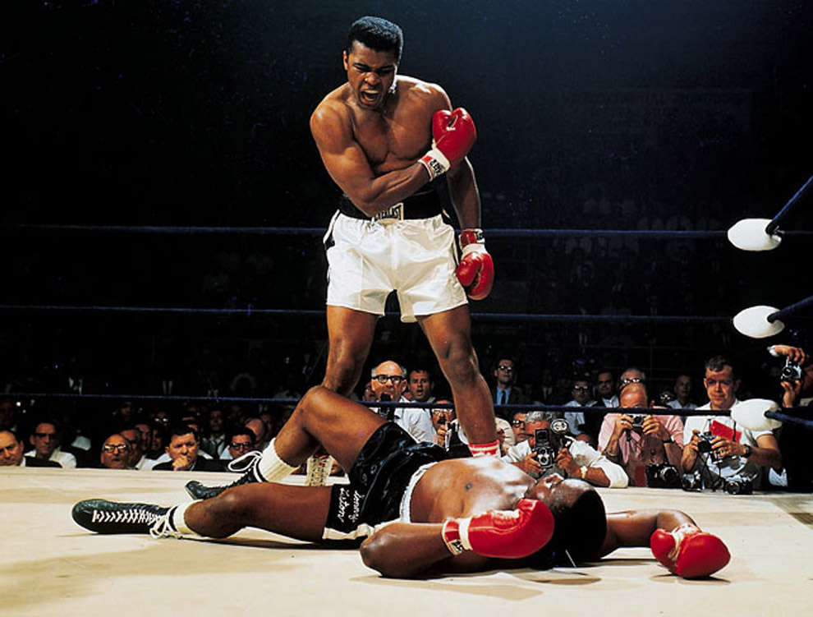
Photo by Neil Leifer

For those of us who love sports, we almost set our watches by the sporting schedule and the deluge of information that surround it. High school football on Friday, college on Saturday, NFL all day Sunday, Monday (and Thursday) night and a steady stream of fantasy updates, NFL Live, SportsCenter and tweets in between.

For those in the sports communication business, this schedule easily sweeps us away into a busy oblivion. In between games and practices, there are news conferences, interviews, articles and scripts to write, statistics to process, tweets to disseminate, bags to pack and planes to catch.

It’s no wonder we don’t have much time to look away from our laptop or phone and really examine the environment around us.
By “environment,” I don’t necessarily mean the faint smell of hot dogs and popcorn that waft up from the concourses and into the press box, or the beauty of Lake Washington stretching out from the east end zone at Husky Stadium at the University of Washington in Seattle.

Rather, I mean the idea that - at that same gorgeous college football stadium - about 70,000 mostly white fans fill that stadium to watch mostly black kids bash heads for their entertainment. I mean the notion that about 20 million girls ages 5 through 18 play organized sports in the U.S., but finding women’s sports on TV or in the news is a challenge. I mean the idea that billionaire owners of sports franchises use the tax dollars of every-day Americans to pay for stadia and arenas that those same people can barely afford to enter. I mean the fact that the same banks that taxpayers bailed out in 2008 are still giving those same billionaire owners millions of dollars to put their names on those same stadia.

In this class, we will be turning our eyes from the games and the screens that show them. We will be immersing ourselves into the other environment.

OBJECTIVES
At the conclusion of this course, the assigned readings, class discussions and completed assignments should have helped you to:
* Develop and improve critical-thinking skills, specifically in the sport media arena
* Gain a cultural and economic sensitivity surrounding such issues
* Navigate the complex, capitalist landscape to identify story ideas
EXPECTATIONS
I expect you to be honest, to come to class, to be prepared, to engage and to be respectful. I also expect you to think critically.

You can expect me to listen to your concerns, to be fair, to provide you with feedback in timely manners, and to help you succeed in this class and beyond.

ACADEMIC INTEGRITY
Familiarize yourself with Quinnipiac University's policy on Academic Integrity. (Available in full here.)

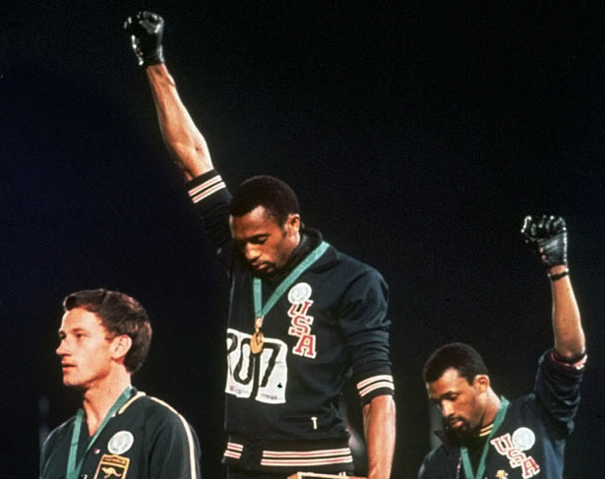
ASSISTANCE
If you have health and/or educational needs, please inform the professor within the first week of the semester. Even if you have already made arrangements with the Office of Academic Services, please make the professor aware within the first week of the semester.
Consistent with its responsibilities, Quinnipiac University provides reasonable accommodations to promote equal educational opportunity. The University provides staff members to ensure compliance with the ADA and Section 504. These staff members work directly with students, faculty and staff regarding reasonable accommodations and other assistance as needed. If you require assistance beyond what your professor can provide, please contact John Jarvis, Coordinator of Learning Services at 203-582-5390 or John.Jarvis@Quinnipiac.edu.
ATTENDANCE
Given that this is a senior0 and graduate-level seminar course, attendance is required. Missing more than one class will negatively impact your grade. Course withdrawal will be recommended if a student misses two or more classes regardless the reason.
CLASSROOM TECHNOLOGY & POLICY
* You are expected to follow the course on mollyyanity.com.
* I will not be using BlackBoard this semester. However, I will be using a live messaging app called SLACK to "email" you and send you readings. All announcements will be made through Slack. Slack can be used from your desktop, laptop, tablet or smartphone.

* When you are in class, phones, tablets and laptops must be stowed, unless otherwise instructed.
DEPARTMENT/UNIVERSITY LEARNING OUTCOMES
The Department of Journalism states that its mission is “to prepare journalism professionals who reflect and can effectively report on the diversity of the human experience.”
Students who graduate with a degree in journalism should be able to:
1. Demonstrate the ability to research, report, write and edit news stories that conform to professional journalism standards, including the ability to apply basic numerical and statistical concepts.

2. Demonstrate command of the techniques used to produce and present news in print, broadcast and digital environments, and understand the interconnectedness of these systems.
3. Demonstrate familiarity with the history of journalism, its social responsibility and the underpinnings of its practice in a culturally and racially diverse society.
4. Understand the implications of the First Amendment and the role journalism plays in democracy.
5. Engage in the ethical practice of journalism.
In addition, Quinnipiac University has established Essential Learning Outcomes and learning paradigms. They include Interpersonal Proficiencies: Written communication, oral communication, responsible citizenship, diversity awareness & sensitivity and social intelligence, and Intellectual Outcomes: Critical thinking & reasoning, scientific literacy, quantitative reasoning, information fluency, creative thinking and visual literacy.
More on these outcomes is available here.

ASSIGNMENTS
DEADLINES: Late assignments are not accepted. For assignments that are to be turned in via email, be sure to cc yourself as “It was stuck in my outbox” is not a valid excuse. There is a reason “DEAD” makes up half the word “deadline.” Once again, late assignments will not be accepted.

READINGS: All readings are to be read before class on the day they are listed on the syllabus. Read them. Take notes. Prepare questions and discussion points. READ. READ. READ. Have I made this clear enough?

For undergraduates, your final grade will be made up of the following:
* Two midterm examinations. 25 points each = 50 points. Bring Blue Books to class. Each exam will cover material in a set of readings, associated lectures, discussions and visuals. Makeup exams will only be given in cases of documented illness, family emergency or civic obligation.

* Final exam. 30 points. The final paper will be cumulative. You will use all the readings and be asked how they intersect with the book “Scoreboard, Baby.” Bring Blue Book to class. NO EARLY FINAL EXAMINATIONS WILL BE ADMINISTERED.

* Engagement. 20 points. This grade is determined by your critical and respectful engagement and thoughtful, prepared participation in class.
For graduate students, your final grade will be made up of the following:
* Three papers. 25 points each = 75 points. You will be required to write 6- to 8-page, double-spaced academic style papers based on readings and discussions held outside of class.

* Engagement. 20 points. This grade is determined by your critical and respectful engagement and participation in class.

* Small-Group Attendance. 5 points. This grade is determined by your critical and respectful engagement and participation in class.

GRADING SCALE*
Grade %/Point Range Grade
> 93 A
90-92 A-
87-89 B+
83-86 B
80-82 B-
77-79 C+
73-76 C
70-72 C-
60-69 D
<59 F
* See Rubric on course website

BOOKS NEEDED FOR THIS CLASS
All students are required to read for this class. The majority of the readings will be available to download for free on the course website. However, ALL students need to purchase, or borrow the following books:

* Scoreboard, Baby: A Story of College Football, Crime & Complicity by Ken Armstrong &
Nick Perry (2010)
* Forty Million Dollar Slaves by William C. Rhoden (2007)

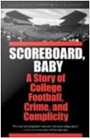

In addition, graduate students will also need the following book:
* Unsportsmanlike Conduct: College Football and the Politics of Rape by Jessica Luther (2016)

